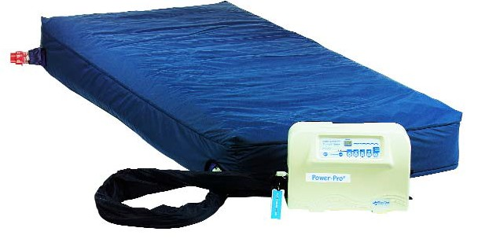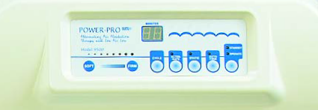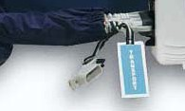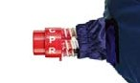

POWER PRO®

Operating, Maintenance & Trouble Shooting

OPERATION
- Place mattress on bed frame and secure to frame with the four corner straps.
- Plug in control unit and place at foot of bed with the foldaway hanger brackets.
- Connect the three hose unit into black manifold and single hose to single port on left side of pump.
- The power switch is located on the right side of pump
- To inflate rapidly push operate button and then auto firm button
- Once inflated punch static button for Low Air Loss Therapy Mode
- Push Alternate button for Low Air Loss/ Alternating Air Therapy Mode
- Select cycle time: 5-95 Minutes per cycle (10 minutes is standard)
- Select patient comfort setting: Based on average patient weight

In emergency:Twist CPR Release Valve in either direction to release air from mattress.

PUMP

36" MATTRESS
Light 1 Light 2 Light 3 Light 4 Light 5 Light 6 Light 7 Light 8
90-130 120-175 160-225 200-295 285-395 375-475 450-575 550-650

42" MATTRESS
Light 1 Light 2 Light 3 Light 4 Light 5 Light 6 Light 7 Light 8
150-200 200-250 250-350 350-400 400-450 440-550 550-650 650-750

48" MATTRESS
Light 1 Light 2 Light 3 Light 4 Light 5 Light 6 Light 7 Light 8
200-300 300-350 350-450 450-550 550-650 650-750 750-875 875-1000

MAINTENANCE

Pump
  - Wash hands and place gloves on hand
  - Place pump, hose on decontamination table or counter
  - Spray with Madacide or other disinfectants. Do not use phenol based disinfectants
  - Wipe down pump and hose with paper towel and dispose
  - Let pump and hose dry for approximately 15 minutes,

Mattress
- Wash hands and place gloves on hand
- Place mattress on decontamination table or counter
- Spray with Madacide or other disinfectants. Do not use phenol based disinfectants
- Wipe down top of mattress with paper towel and let sit for approximately 15 minutes
- Turn mattress over and repeat the cleaning process.
- Let the mattress hang dry in a well-ventilated area between 12-24 hours.
- Covers can be removed and washed in a gentle cycle using disinfectants.
- Put in dryer only in spin cycle to remove excess moisture, do not use heat.

TROUBLESHOOTING

Problem Possible Causes Action

Mattress not inflating 1. No Power 1.Check plug in outlet, check fuse

  - CPR Valve opened 2. Twist to close position
  - Air Rail or Hoses Kinked 3. Check that hoses are not impeded
by bed rail or other obstruction
  - Hose not connected to pump 4. Insert hose firmly to manifold

Power Failure 1. Power Surge 1. Turn power switch off then on
- Blown fuse 2. Change fuse
- Power cord is not plugged in 3. Plug power cord into outlet

Pump not inflating 1. Pump in standby mode 1. Press operate button, select
auto firm, or alternate mode.
- Not responding to mode 2. Turn Power switch on then off
to reset.
- Filter is dirty 3. Remove filter located under the carry handle of pump. Vacuum or rinse under water to remove excess dust.
- Excess Noise 4. Return for authorized technical service.

7-11 Suffern Place, Suffern, NY 10901
Blue Chip
Toll Free: 800 795-6115 • Fax: 845 369-7633

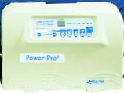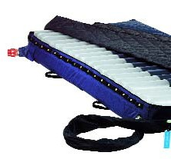 Medical Products Inc.
Website: www.bluechipmedical.com

