Posey Fall Mats
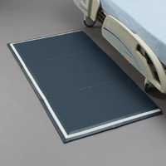
RECOMMENDED USE: Patients at risk for falls.
- Helps reduce impact forces by up to 85%.
- Tested for shock absorbency.
- EVA foam.
- Wipe clean vinyl cover.
- Non-skid bottom.
- Tri-fold design with convenient carrying handle.
- One-inch (3 cm) thick foam creates low profile edge.
- Helps provide full coverage of the bed exit area.
6027R - Added hard plastic on the beveled edge to help Floor Cushion lay flat and minimize curling. Yellow handle can be hung behind doors and is easier to carry.
6023 | Beveled | Flat: 70"L x 38"W x 1"H  (178 cm x 97 cm x 3 cm)  Folded: 24"L x 38"W x 3"H  (61 cm x 97 cm x 8 cm)
6027R | Beveled, Posey Glow | Flat: 70"L x 38"W x 1"H  (178 cm x 97 cm x 3 cm)  Folded: 24"L x 38"W x 3"H  (61 cm x 97 cm x 8 cm)

